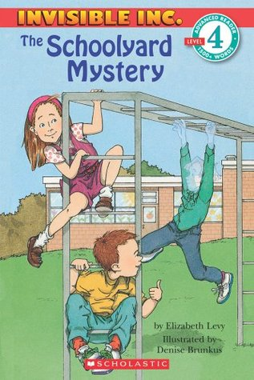

**Who**: Attention all Second and Third Grade students

**What**: Elizabeth Levy Writing/Drawing Activity

Amazing author, Elizabeth Levy, will be visiting our school on March 20, 2014. To celebrate her arrival, we invite you to complete an activity based on her ever popular “Invisible Inc.” series. These stories combine mystery and adventure as invisible characters follow clues to solve mysteries of all kinds.

**Activity:** Imagine you are invisible for one whole day. What kinds of adventures will you have? Write about how you will spend your day as an invisible boy or girl. Don’t forget to include a drawing to accompany your writing.

**When**: Entries must be handed in by Wednesday, March 12, 2014.

**Where**: Entries must be submitted to Mr. Mullarkey in the library.

**Why**: To celebrate the arrival of Elizabeth Levy and earn the chance to share dessert with her! All students who complete the activity will be entered into a drawing, and several students will be selected randomly to have dessert with Ms. Levy.

Please be sure to include your name and grade!